**Example for HEPYSTS – listener configuration**

**Login as grid user to NodeA**

srvctl config scan_listener

srvctl modify scan_listener -endpoints ‘TCP:1551’

srvctl config scan_listener

**Just to verify**

cd $TNS_ADMIN

view listener.ora

**Bounce listener**

srvctl stop scan_listener

srvctl start scan_listener

**Login to Node A under oracle**

ps-ef | grep pmon

sqlplus / as sysdba

show parameter remote_listener

## Should be already set just verify if not set to appropriate value

alter system set remote_listener=’xhepydb2s-scan:1551’;

dgmgrl /

show configuration

show database verbose ‘HEPYSTS_xhepydbw2scl’

!! could be already there

edit database 'HEPYSTS_xhepydbw2scl' set property DGConnectIdentifier = '(DESCRIPTION=(ADDRESS=(PROTOCOL=TCP)(HOST=xhepydbw2s-scan.aetna.com)(PORT=1551))(CONNECT_DATA=(service_name=HEPYSTS_xhepydbw2scl)))';

show database verbose ‘HEPYSTS_xhepydbw2scl’

**Login to NodeA as grid**

srvctl config listener -l listener

srvctl modify listener -l listener -endpoints ‘TCP:1521,1551/IPC:HEPYSTS_IPC’

srvctl config listener -l listener

cd $TNS_ADMIN

vi listener.ora

Make changes to look like this

HEPYSTS example

(ADDRESS = (PROTOCOL = IPC)(KEY = HEPYSTS_IPC))

(ADDRESS = (PROTOCOL = IPC)(KEY = HEPYDBA_IPC))

(ADDRESS = (PROTOCOL = tcp)(host = xhepydbw2as)(port = 1655))

SID_LIST_LISTENER =

(SID_LIST =

# HEPYDBA Begin ANSIBLE MANAGED BLOCK

(SID_DESC =

(ORACLE_HOME = /oradb/app/oracle/product/19.22.0/db_1)

(SID_NAME = HEPYDBA)

)

# HEPYDBA End ANSIBLE MANAGED BLOCK

)

HEDWSTS example

(ADDRESS = (PROTOCOL = IPC)(KEY = HEDWSTS_IPC))

lsnrctl status

Bounce listener

lsnrctl stop listener

lsnrctl start listener

**Login to NodeA under oracle**

cd $TNS_ADMIN

vi tnsnames.ora

**Change port to 1551**

**Same on NodeB**

**Example for HEDWSTS – listener configuration**

**Login as grid user to NodeA**

srvctl config scan_listener

srvctl modify scan_listener -endpoints ‘TCP:1551’

srvctl config scan_listener

**Just to verify**

cd $TNS_ADMIN

view listener.ora

**Bounce listener**

srvctl stop scan_listener

srvctl start scan_listener

**Login to Node A under oracle**

ps-ef | grep pmon

sqlplus / as sysdba

show parameter remote_listener

## Should be already set just verify if not set to appropriate value

alter system set remote_listener=’xhedwdb2s-scan:1551’;

dgmgrl /

show configuration

show database verbose ‘HEDWSTS_xhedwdbw2scl’

!! could be already there

edit database 'HEDWSTS_xhedwdbw2scl' set property DGConnectIdentifier = '(DESCRIPTION=(ADDRESS=(PROTOCOL=TCP)(HOST=xhedwdbw2s-scan.aetna.com)(PORT=1551))(CONNECT_DATA=(service_name=HEDWSTS_xhedwdbw2scl)))';

show database verbose ‘HEDWSTS_xhedwdbw2scl’

**Login to NodeA as grid**

srvctl config listener -l listener

srvctl modify listener -l listener -endpoints ‘TCP:1521,1551/IPC:HEDWSTS_IPC’

srvctl config listener -l listener

cd $TNS_ADMIN

vi listener.ora

Make changes to look like this

(ADDRESS = (PROTOCOL = IPC)(KEY = HEDWSTS_IPC))

(ADDRESS = (PROTOCOL = IPC)(KEY = HEPYDBA_IPC))

(ADDRESS = (PROTOCOL = tcp)(host = xhedwdbw2as)(port = 1655))

SID_LIST_LISTENER =

(SID_LIST =

# HEPYDBA Begin ANSIBLE MANAGED BLOCK

(SID_DESC =

(ORACLE_HOME = /oradb/app/oracle/product/19.22.0/db_1)

(SID_NAME = HEPYDBA)

)

# HEPYDBA End ANSIBLE MANAGED BLOCK

)

HEDWSTS example

(ADDRESS = (PROTOCOL = IPC)(KEY = HEDWSTS_IPC))

lsnrctl status

Bounce listener

lsnrctl stop listener

lsnrctl start listener

**Login to NodeA under oracle**

cd $TNS_ADMIN

vi tnsnames.ora

**Change port to 1551**

**Same on NodeB**

**Example for (repeat same for HEPYSTS and HEDWSTS) –service configuration**

**Add Targets to OEM if not already there.**

**Update OEM targets with 1551 port**

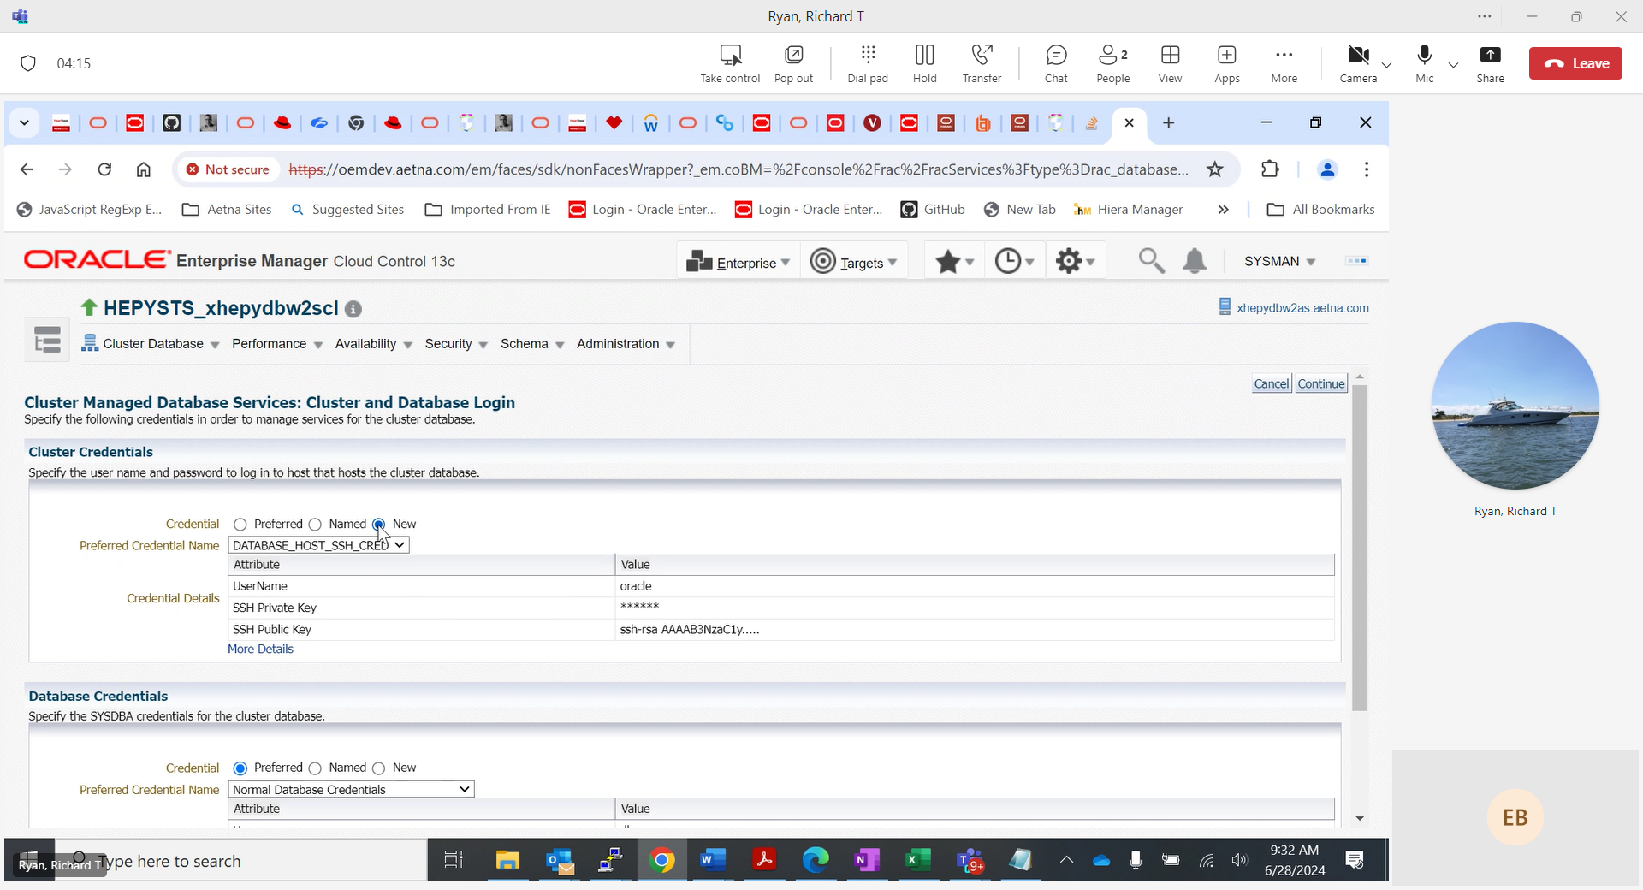

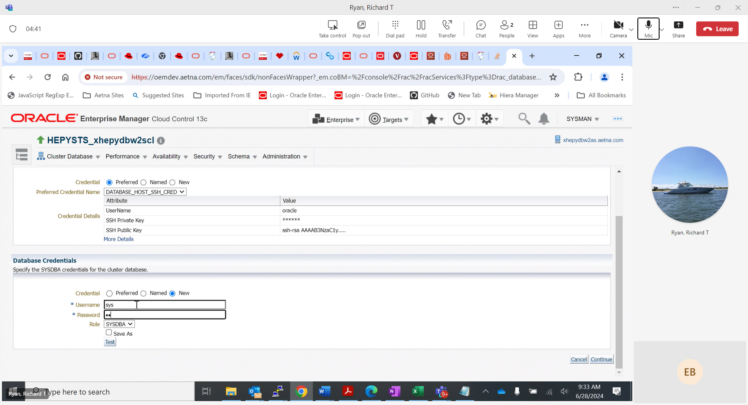

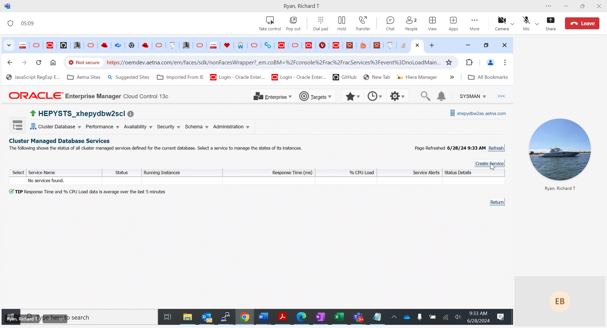

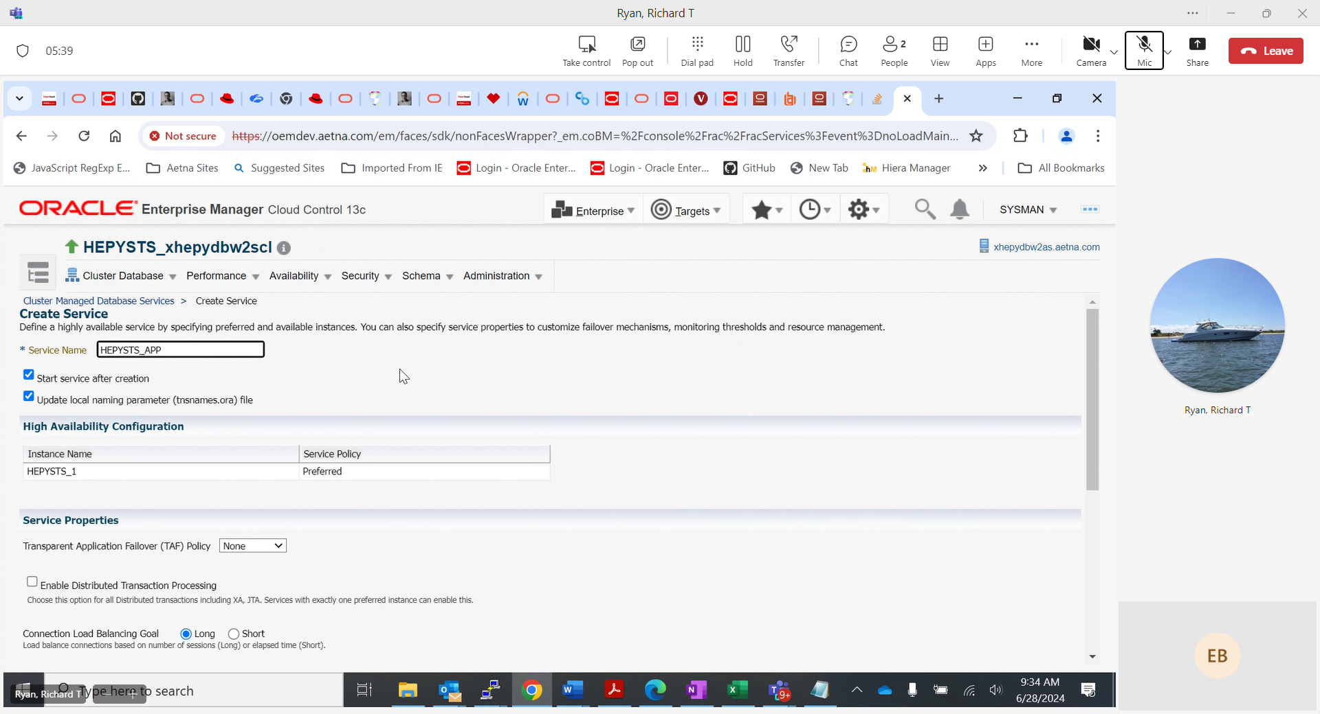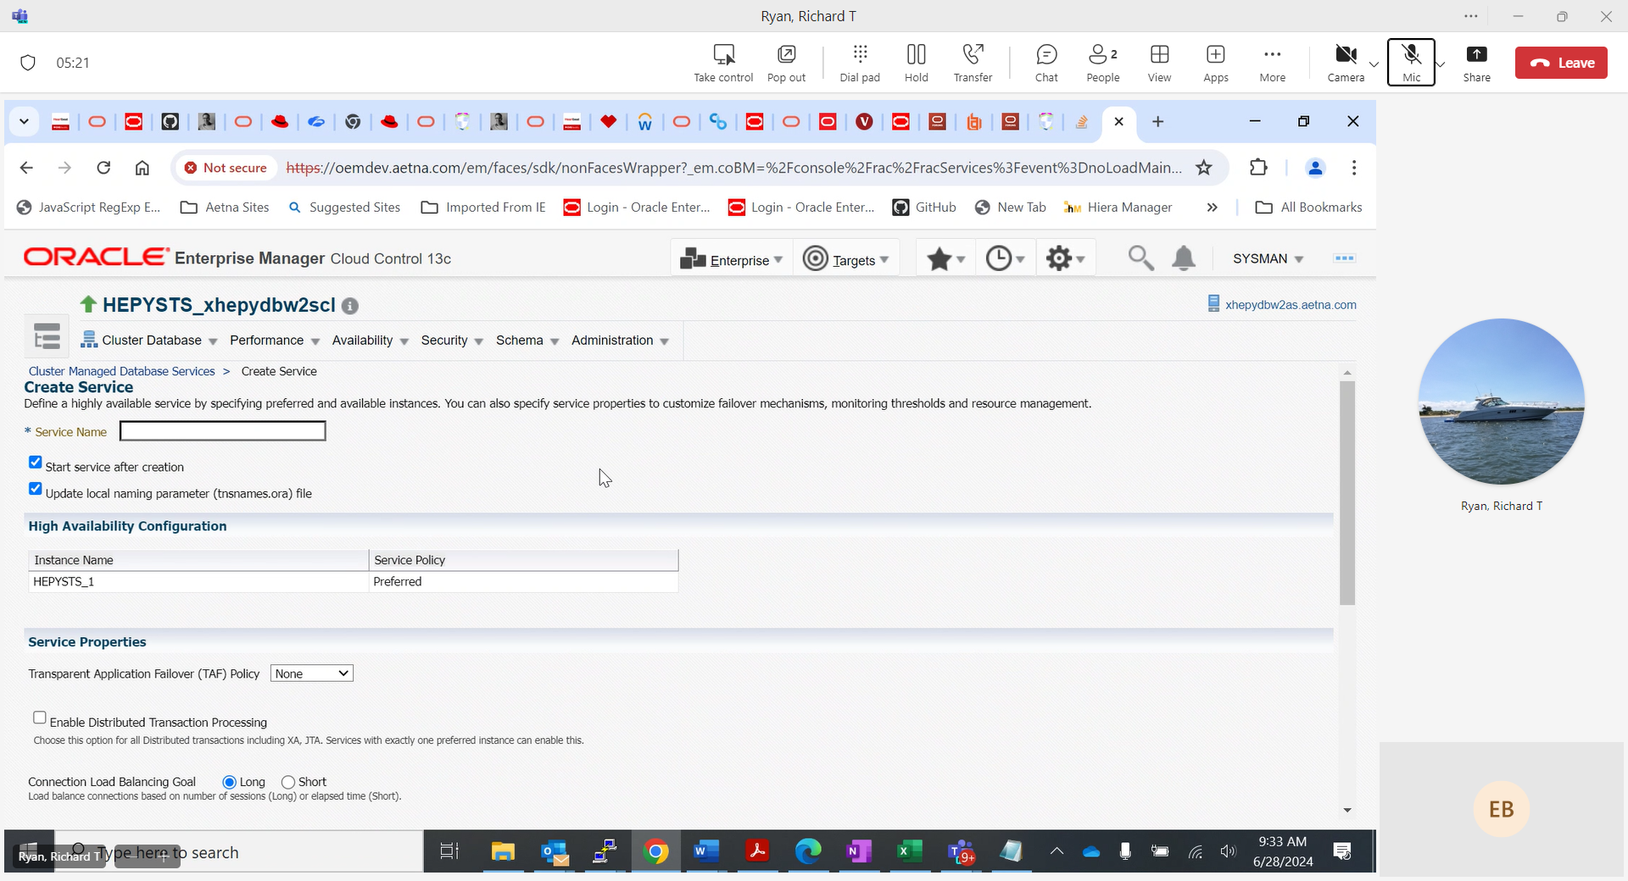

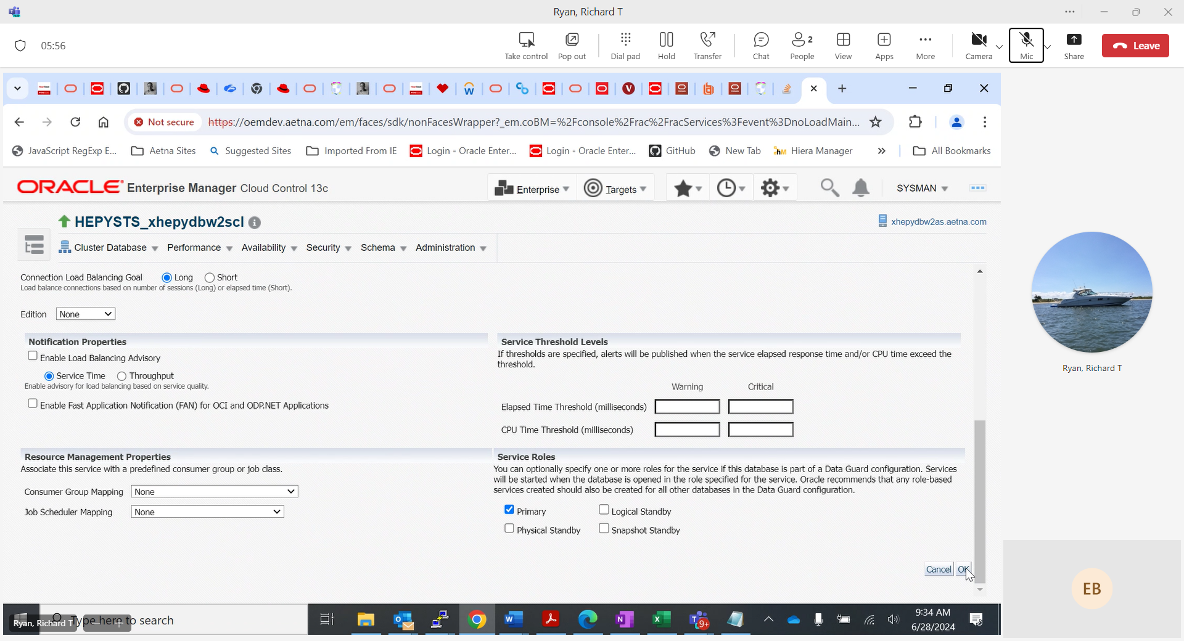

HEPYSTS example:

Login to NodeA as oracle

srvctl config service -d HEPYSTS_xhepydbw2scl -s HEPYSTS_APP

srvctl status service -d HEPYSTS_xhepydbw2scl -s HEPYSTS_APP

HEDWSTS example:

Login to NodeA as oracle

srvctl config service -d HEDWSTS_xhedwdbw2scl -s HEDWSTS_APP

srvctl status service -d HEDWSTS_xhedwdbw2scl -s HEDWSTS_APP

Modify tnsnames. ora entry on both NodeA and NodeB. Example below how it should look on HEPYSTS server

cd $TNS_ADMIN

vi tnsnames.ora

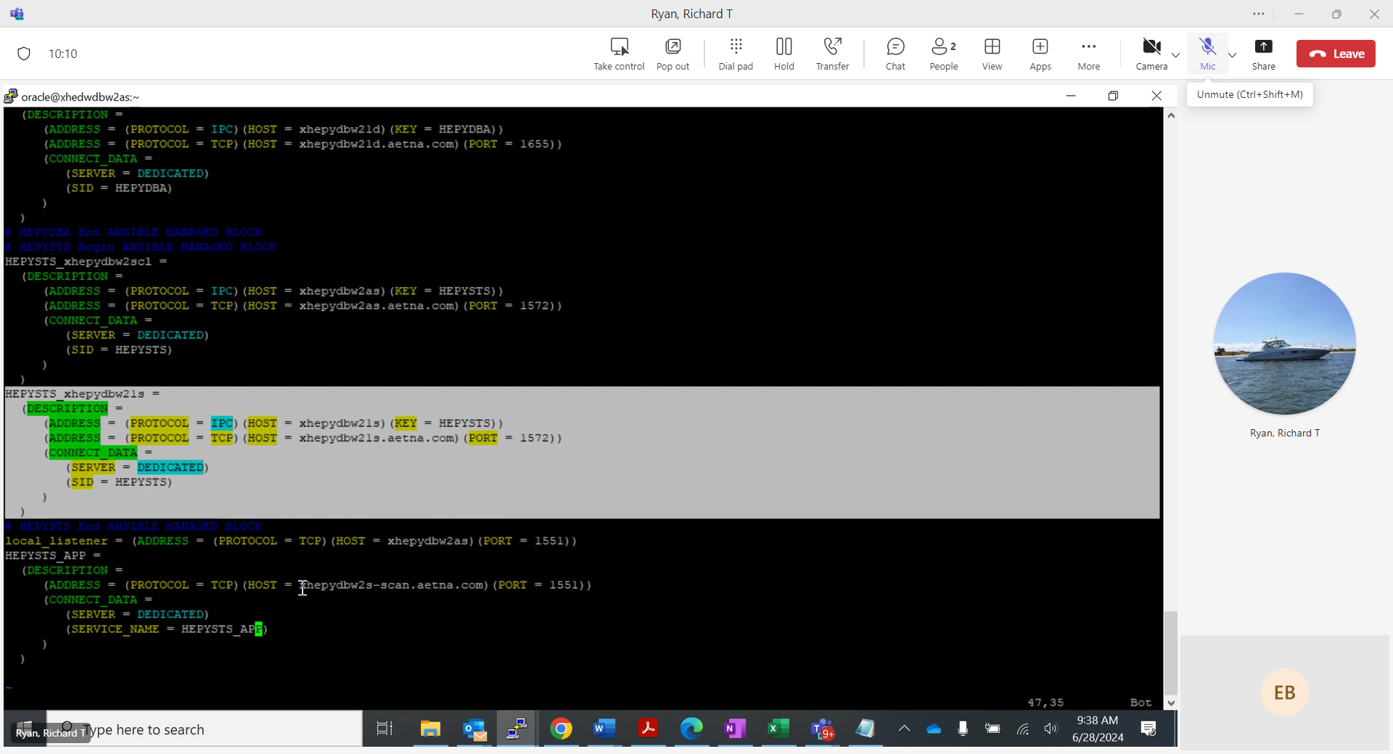

Do it on Nodeb tnsnames.ora as well

~~Double check to make sure HEPYSTS_APP service role set to PRIMARY and it not running before switch over. See HEDWSTS example~~

How to start service and test connection strings if needed

srvctl start service -d HEPYSTS_xhepydbw2scl -s HEPYSTS_APP

srvctl start service -d HEDWSTS_xhedwdbw2scl -s HEDWSTS_APP

from any none RAC boxes

sqlplus AID/xxx@'(DESCRIPTION = (ADDRESS_LIST = (ADDRESS = (PROTOCOL = TCP)(HOST = xhepydbw2s-scan.aetna.com)(PORT = 1551)) (ADDRESS = (PROTOCOL = TCP)(HOST = xhepydbw21s.aetna.com)(PORT = 1573))) (CONNECT_DATA = (SERVICE_NAME = HEPYSTS_APP)))'

sqlplus AID/xxx@'(DESCRIPTION=(ADDRESS=(PROTOCOL=tcp)(HOST=xhepydbw21s.aetna.com)(PORT=1572))(CONNECT_DATA=(SID= HEPYSTS)))'

srvctl stop service -d HEPYSTS_xhepydbw2scl -s HEPYSTS_APP

srvctl stop service -d HEDWSTS_xhedwdbw2scl -s HEDWSTS_APP